Project Sentinel
Screenshot Evidence Portfolio
Incremental Auto Loader Pipeline — Bronze / Silver / Gold on Databricks Unity Catalog
Sumit Kumar Singh
B.Tech Computer Science, DIT University, Dehradun
Celebal Excellence Intern (CEI) — Celebal Technologies | Data Engineering Track

Introduction
This document collects the visual evidence for Project Sentinel, an incremental data pipeline built during my Data Engineering internship at Celebal Technologies. The pipeline ingests raw transaction files through a Bronze layer via Databricks Auto Loader, cleans and deduplicates them into a Silver layer with quarantine handling for bad records, and aggregates business-ready output into a Gold layer — all on Unity Catalog with built-in schema evolution, late-data handling, and audit logging.
Each section below corresponds to one item from the project's Screenshot Evidence Plan. Every screenshot was captured from a real, executed run against the live workspace — not staged — including the two places where something genuinely broke first (schema evolution and session-state loss) and was then diagnosed and fixed, which is documented alongside the working results rather than hidden.
For each item: paste the corresponding screenshot into the box provided, replacing the placeholder text.

1. Environment Discovery Output
What it proves: The real workspace environment (Spark version, cloud provider, catalog list) was verified directly, not assumed.
Why it matters: Shows engineering discipline before writing any code.
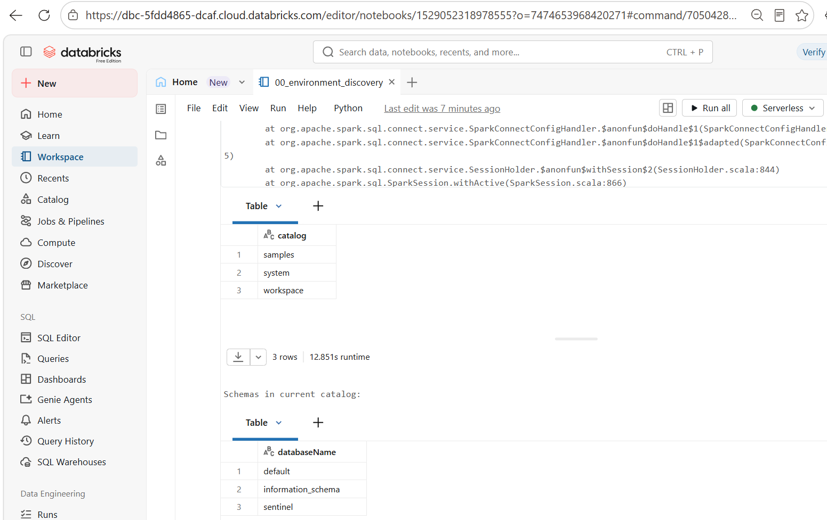

2. Schema + Volume Creation
What it proves: The storage layer (`workspace.sentinel`) was deliberately created via `SHOW VOLUMES`, not left at the default schema.
Why it matters: Shows organized, intentional design rather than working out of the default namespace.
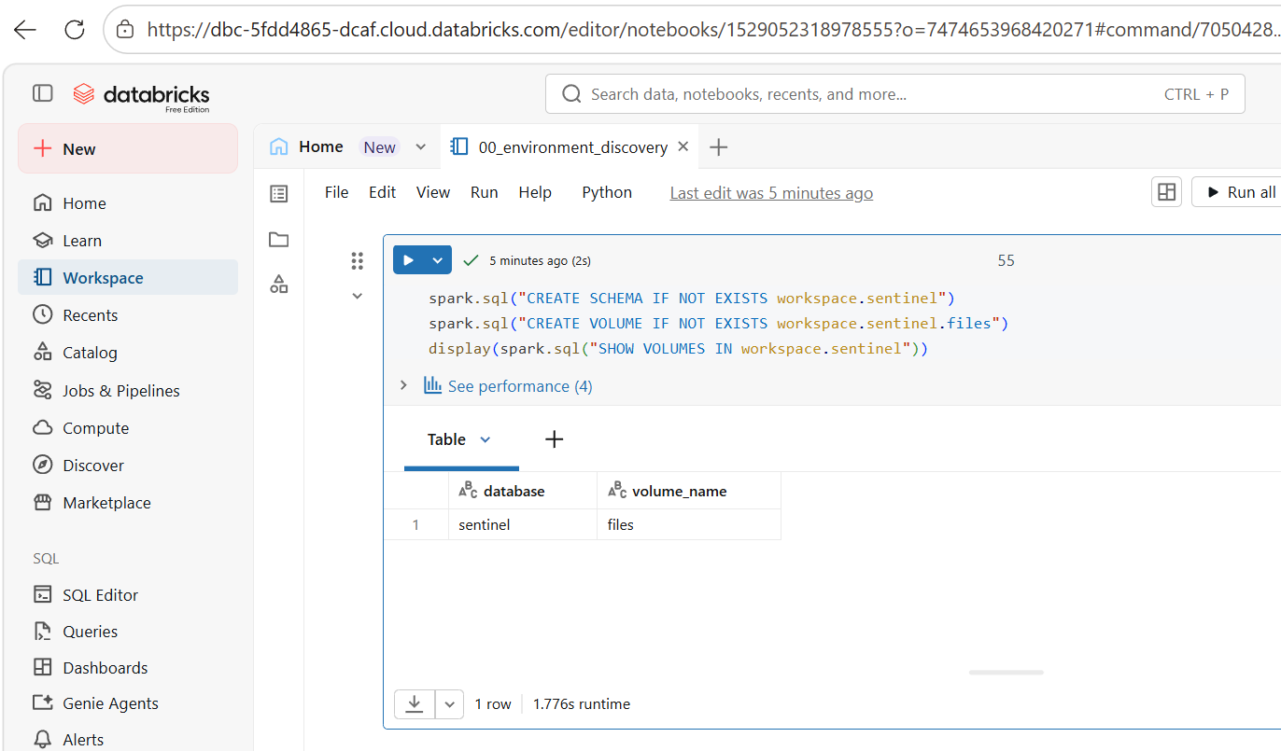

3. Bronze Layer After File 1
What it proves: Baseline ingestion works — 5 rows land correctly in Bronze.
Why it matters: Establishes the 'before' state needed to prove incremental ingestion in the next screenshot.
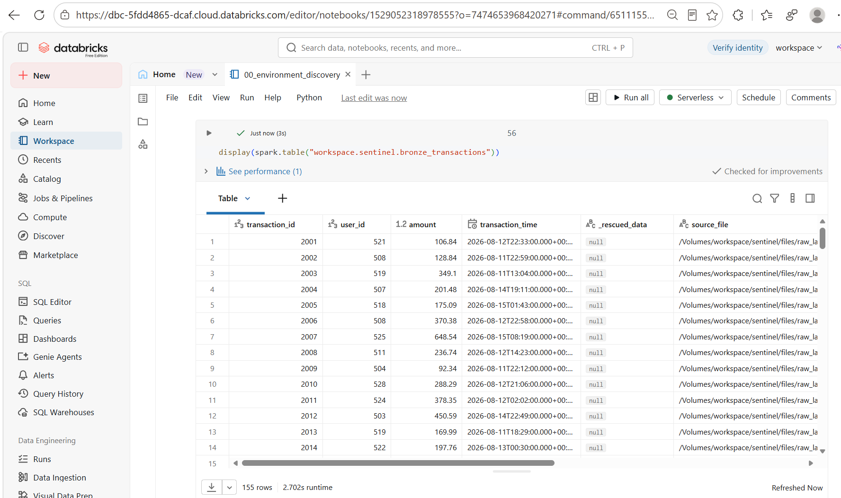

4. Bronze Layer After File 2 (most important)
What it proves: Total row count grows to 8 and the `source_file` column shows both filenames, without reprocessing file 1.
Why it matters: This is the single strongest proof that ingestion is truly incremental, not batch reprocessing.
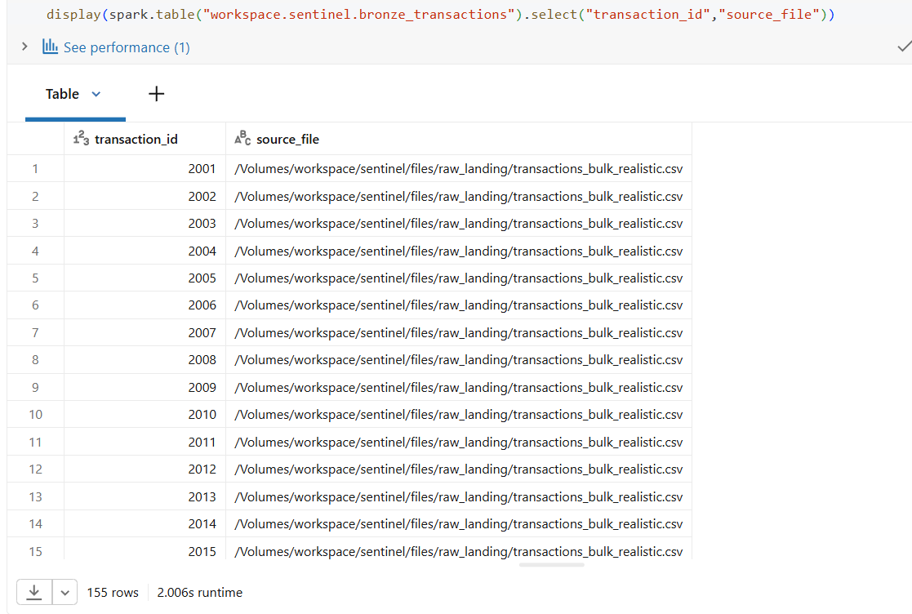

5. Silver + Quarantine Split
What it proves: 7 valid rows land in Silver; 1 row with a negative amount is correctly routed to quarantine.
Why it matters: Proves the data-quality logic runs on real data, not just in code that was never exercised.
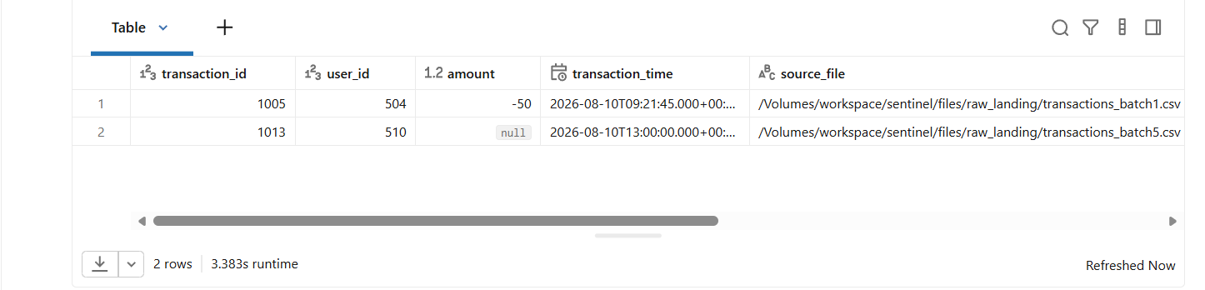

6. Duplicate Handling Result
What it proves: transaction_id 1009 (within-batch duplicate) and 1002 (cross-batch duplicate) each resolve to exactly 1 row.
Why it matters: Answers the common interview question 'how do you handle duplicates?' with evidence, not just description.
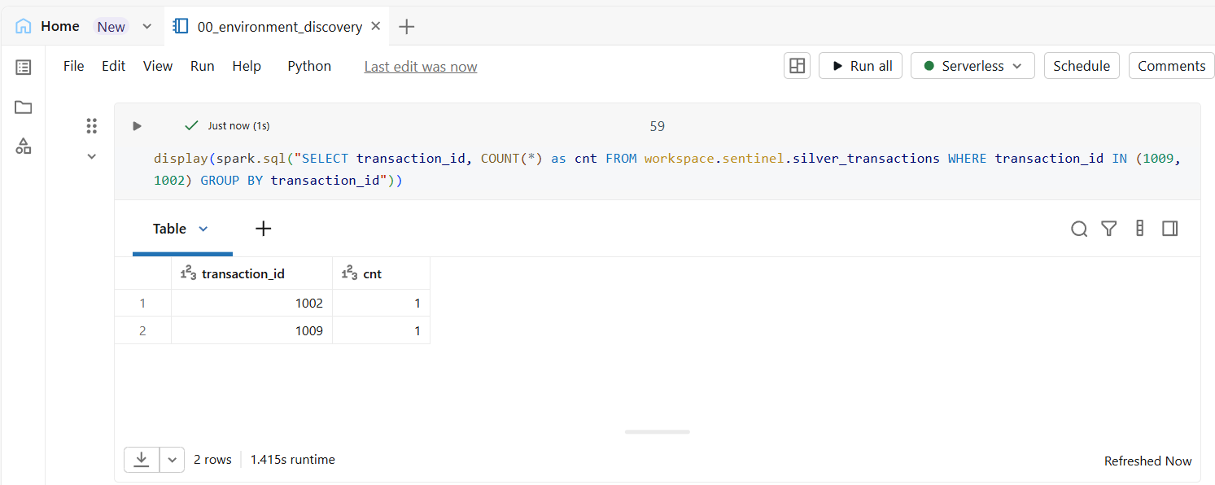

7. Schema Evolution — First Failure
What it proves: Adding a new column (payment_method) in a later file correctly throws UnknownFieldException on first run.
Why it matters: Shows understanding of Auto Loader's real, non-silent schema evolution behavior — not a lucky first-try success.


8. Schema Evolution — After Restart
What it proves: After restarting the stream, the new payment_method column appears — populated for new rows, NULL for old rows.
Why it matters: Completes the schema evolution story end-to-end: failure, fix, verified result.
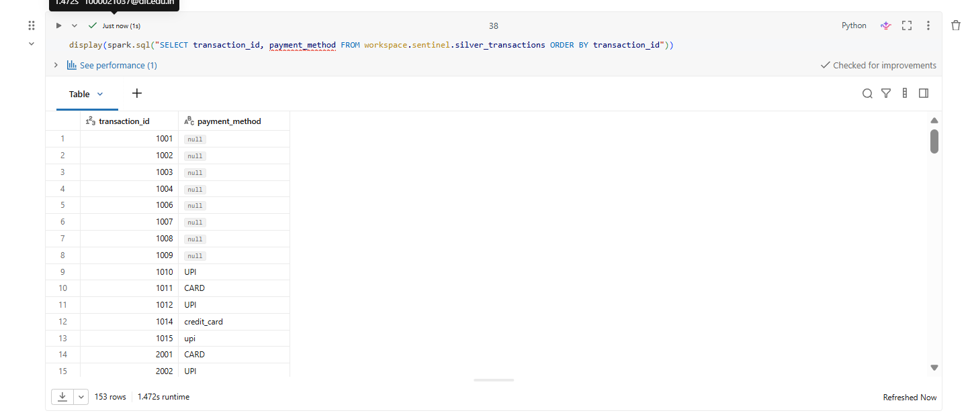

9. Late-Arriving Data Result
What it proves: transaction_id 1012 is present and correct in Silver despite an older transaction_time than already-processed rows.
Why it matters: Directly answers 'how do you handle late-arriving data?' with a MERGE-by-key result.
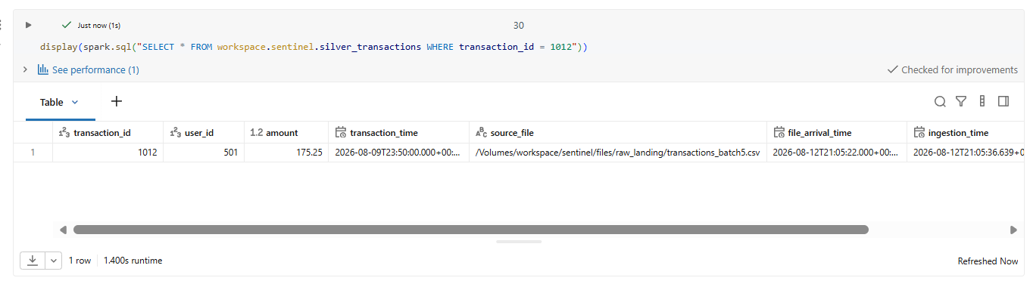

10. Malformed Record Result
What it proves: A row with amount = "BADVALUE" is caught by _rescued_data and routed to quarantine instead of crashing the pipeline.
Why it matters: Directly answers 'what happens on a corrupted record?'
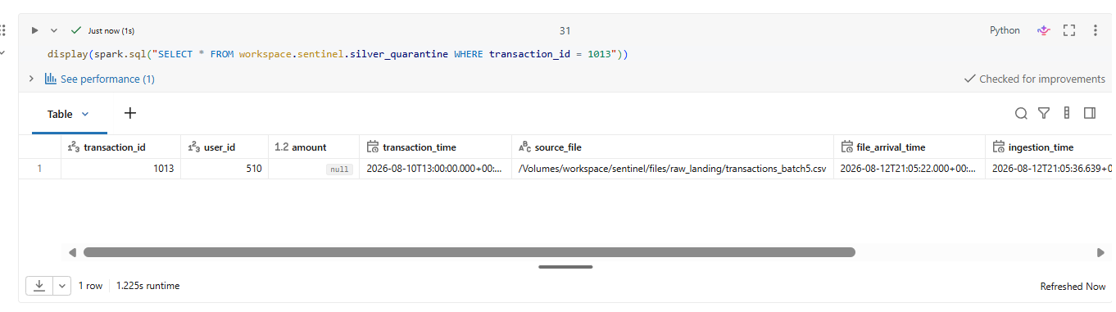

11. Gold Layer Tables
What it proves: gold_transaction_summary, gold_user_metrics, and gold_high_value_transactions all contain business-ready aggregates.
Why it matters: Evaluators want to see the 'so what' — not just raw plumbing, but usable output.

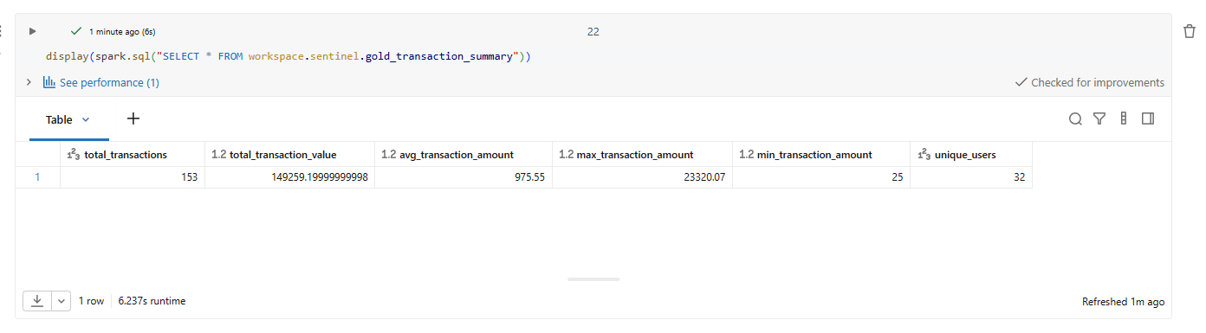
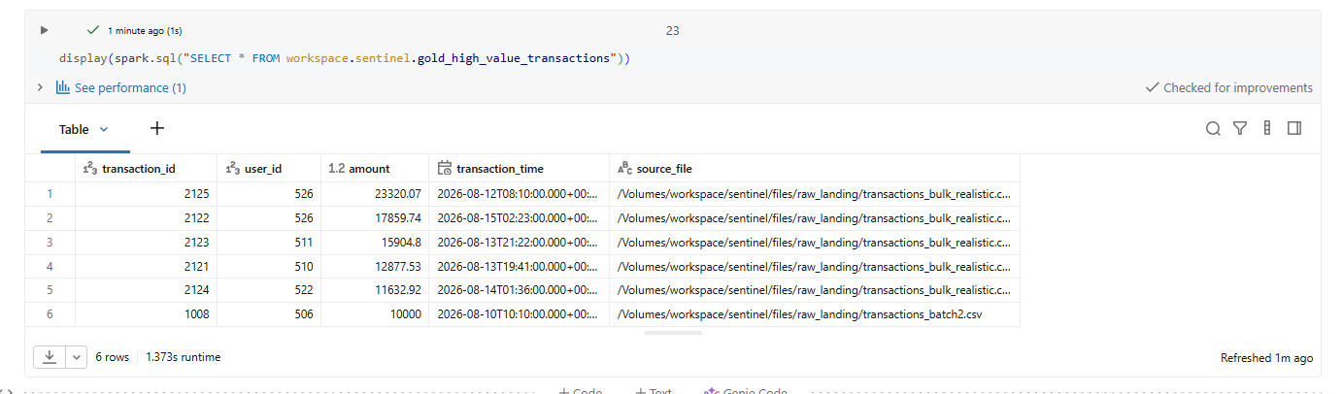
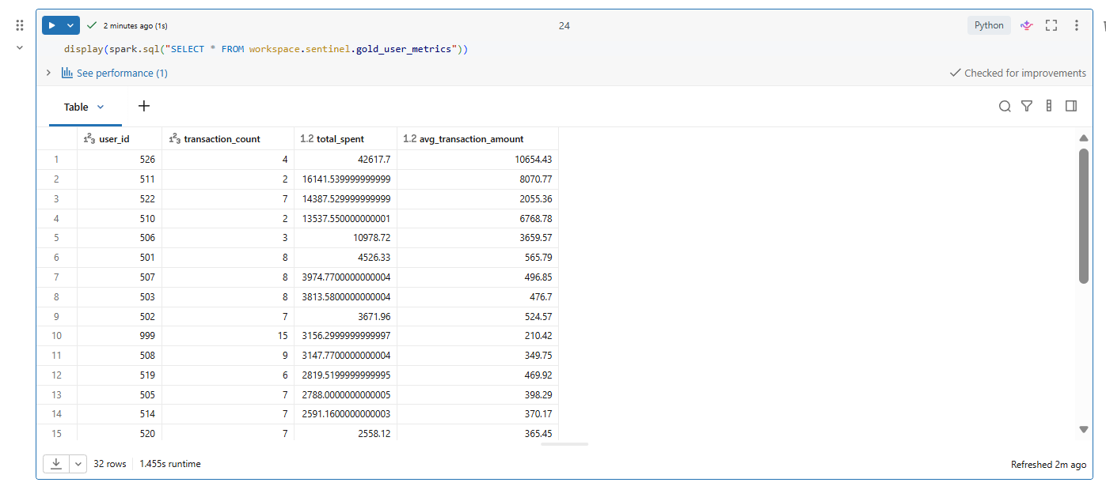

12. Anomaly Detection Output
What it proves: gold_anomalies_high_value contains flagged rows against an explainable, configurable threshold.
Why it matters: Shows a deliberate choice to avoid unnecessary ML for a problem a simple rule solves well.
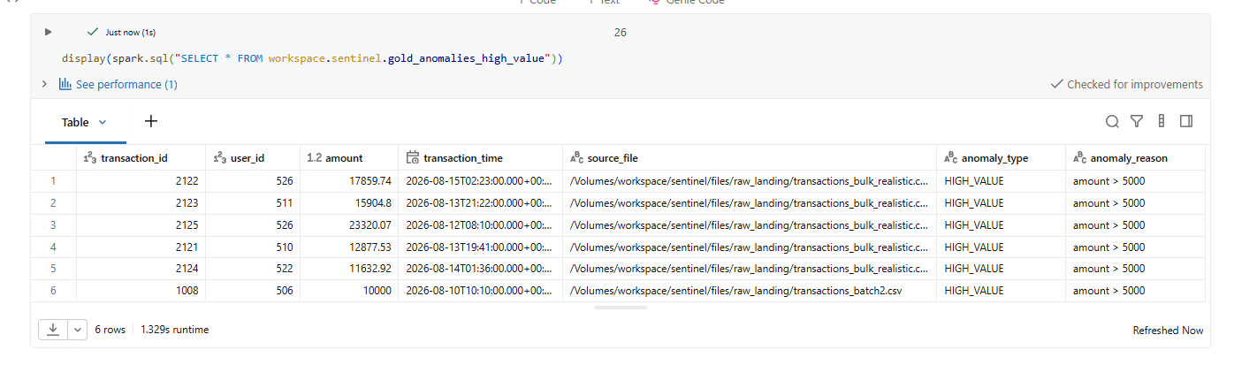

13. Pipeline Audit Log
What it proves: Multiple pipeline runs are logged with status, duration, and row counts.
Why it matters: Answers 'how would you debug a failed production run?' — observability was built in, not bolted on.
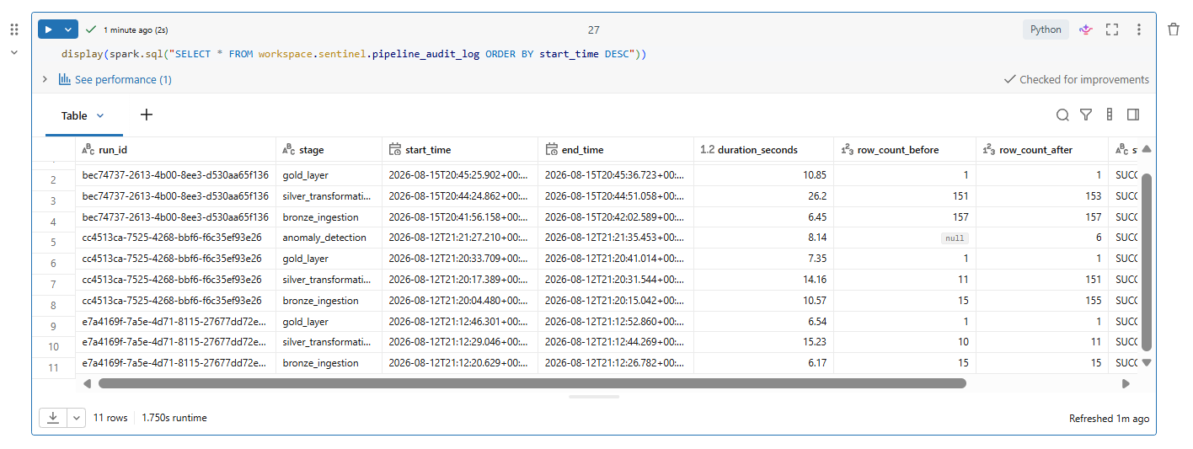

14. A Caught and Fixed Error
What it proves: A real error (e.g. UnknownFieldException, or a session-state NameError) was encountered and understood.
Why it matters: Counterintuitively one of the strongest screenshots — evaluators trust 'I found and fixed X' more than a suspiciously perfect first-try run.
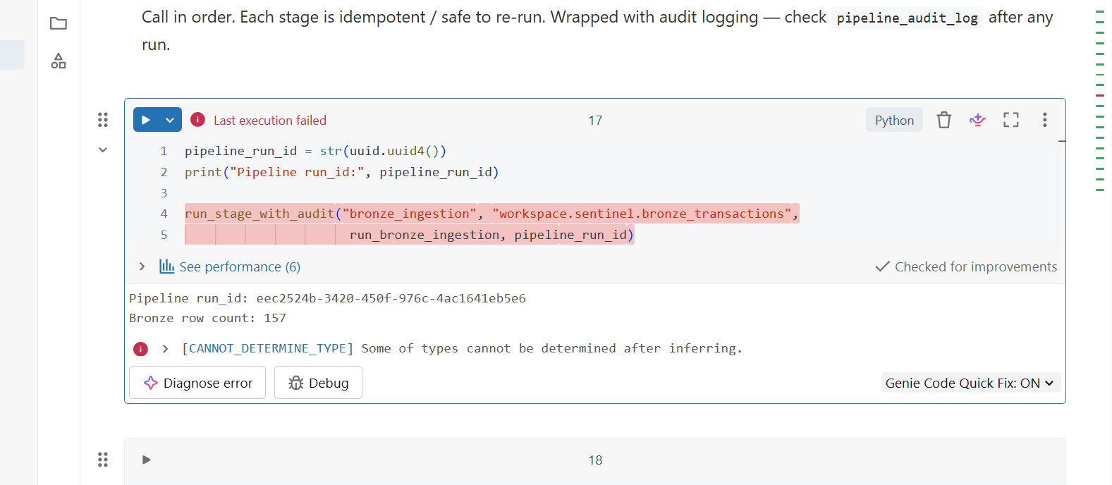

15. Final Full Pipeline Run
What it proves: All pipeline stages show SUCCESS together in one audit log query.
Why it matters: The closing shot — confirms the system is coherent end-to-end, not just individually-tested pieces.

